# PD5OO-II

**TFT-LCD Display**

## & Characters/background colors can be changed freely

**APD5OO-II can show QR Code**

APD5OO-II can show full screen images when standby



A Low **power consumption: PD5OO-II is 1.SW**

## APD5OO-II: 4O*8O dot matrix

# PD5OO-II

TFT-LCD Customer Display

# Specification

|  |  |  |  |
| --- | --- | --- | --- |
| General | Display Method | TFT - LCD Display 15 inch COLOR PANEL ) | |
| Pattern | 20columns X 2line )/(20coIums X 4 line) .  Show images full screen when standby state | |
| Brightness | >350cd/m2 | |
| Resolution | 80O*48O | |
| Character font | 40*80 dot matrix | |
| Character type | 95 Alphanumeric. 32 international characters | |
| Character size | 10.8 I H X 5.4 I W ) mm | |
| Dot size I XP Y | O.135 X 0.135 mm | |
| Active area | 1D8 *L L)* mm X 24.8 I W mm | |
| Pole Dimension | Per support length. 163 I L X 27.65 I DIA  80 L ) X 27.65 I DIA:) mm | mm/ |
| Base Dimension | 126 I L X 89 I W X 13.5 I H mm | |
| Viewing Angle | Max.135” | |
| Horizontal Rotation | Max.355° | |
| Weight | 490 grams/5D6grams | |
| Commands Mode | | 15 kind s, E.g LD22D, ESC/POS, AEDEX, UTC/S, UTC/P, ADM788,  DSP80D, CD5220, EMAX, LOGIC CONTROL etc | |
| Language Support | | CP437, Katakana, CP850, CP860, CP863,CP865, WCP1252, CP857,  WCP125D, WCP1253,WCP1255, WCP1251, CP8g6, CP852, CP737, CP858, CP8 64,WCP1257, WCP1258 . Tai I CP874 J. CP936 | |
| Interface | | RS-232 ( serial! /USB | |
| Connection | Bau d | Direct connection 960D/1920D/384D0/57600/1152fXI bps | |
| Reliability  Power | MTBF  Consumption | 30000 hours  5-24 VDC | |
| Safety | EMC standards  Safety standards | FCC› CE› ROHS | |



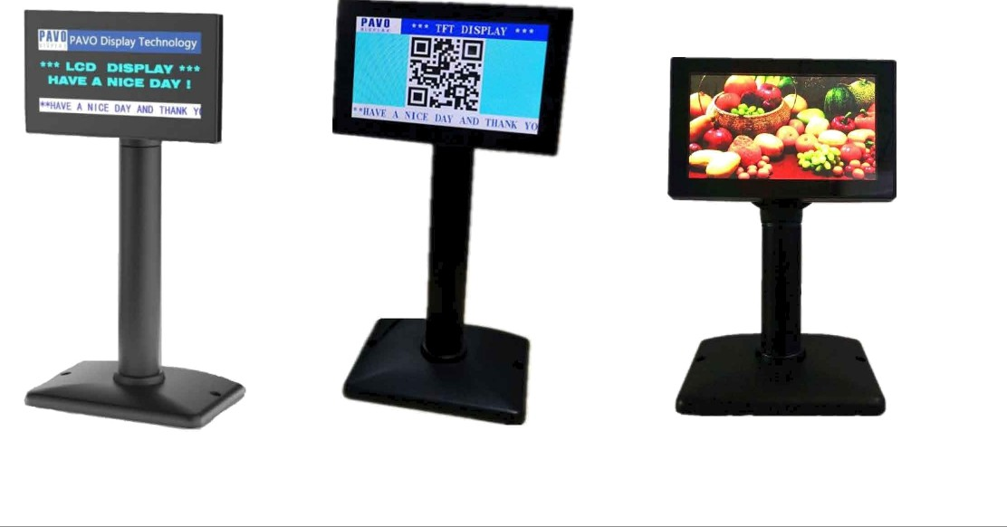

Supports 15 command modes included EPSON etc.

Power supply from 5V to 24V to prevent any mindless use of improper power input.

Easy connectivity to a wide range of POS products.

OPOS/JPOS driver is standard.